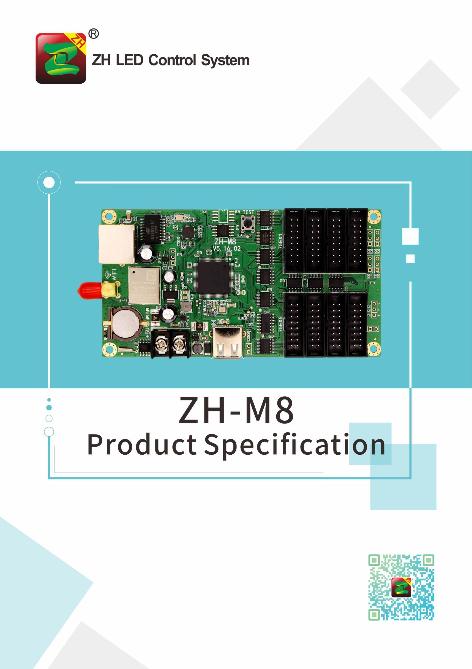

**ZH-M8 Specification**

**I. Function Introduction:**

1. **Multi-platform control:** Support PC, Android and IOS.
2. **Fast transmission rate:** Use HTTP protocol and data compression, data transmission is smaller and faster.
3. **Background transmission efficient:** Proprietary algorithm, small data size, higher efficiency.
4. **Simple operation:** Simple UI design, debugging and use do not affect each other, and zero learning cost.
5. **Multilayer overlay processing:** Background and foreground do not affect operational efficiency.
6. **WiFi +USB dual communication:** Subtitle data can be transmitted through WiFi or USB.
7. **Support various indoor and outdoor unit board:** HUB75E interface match with various kind of the unit board.
8. **Support module line type automatic scanning:** Line type automatic scanning.
9. **Support program timing play, fixed time play, designated time play:** The program can play at will.
10. **Support rainbow word, background, pictures and other materials:** Support all kinds of common materials.
11. **Support special chips:** Such as ICN2038S.
12. **Support external interface expansion:** Such as temperature sensor.

**II. Detail Parameters**

|  |
| --- |
| **Operating system:**  **PC device support:** XP, Win7, Win8 and Win10.  **Mobile terminal support:** Android(Android), IOS. |
| **Display effect:** support software dynamic background, magic run side overlay play. |
| **Running type:** phantom running, support the whole screen running/multi partition running/custom running. |
| **Play type:** support multi-program sequential play/timing play/fixed-length play/time-sharing play/lock single program play. |
| **Adaptive range:** support various 75E interface unit board. |
| **Supporting software**  **PC side :** LED player V5  **Mobile terminal:** LED Mobile (color), support multi-program editing/multi-area display/multi-language version. |
| **Area type:** subtitle/time/analog dial/temperature. |
| **Communication mode:** WIFI, stable speed. USB, once plug and play. |
| **Sensor:** Temperature sensor |
| **Clock:** support |
| **Working voltage:** + 4.5v ~6V |
| **Maximum power consumption:** <1W |
| **Operating temperature:** -30°C~70°C |

**III. Loading Area**

|  |  |  |  |
| --- | --- | --- | --- |
| **Model** | **HUB Port** | **Loading Area** | **Storage** |
| ZH-M8 | 8*hub 75E | 1024*128 512*256  max width：1024； max height：512 | 16M |

**IV. Hardware Introduction**

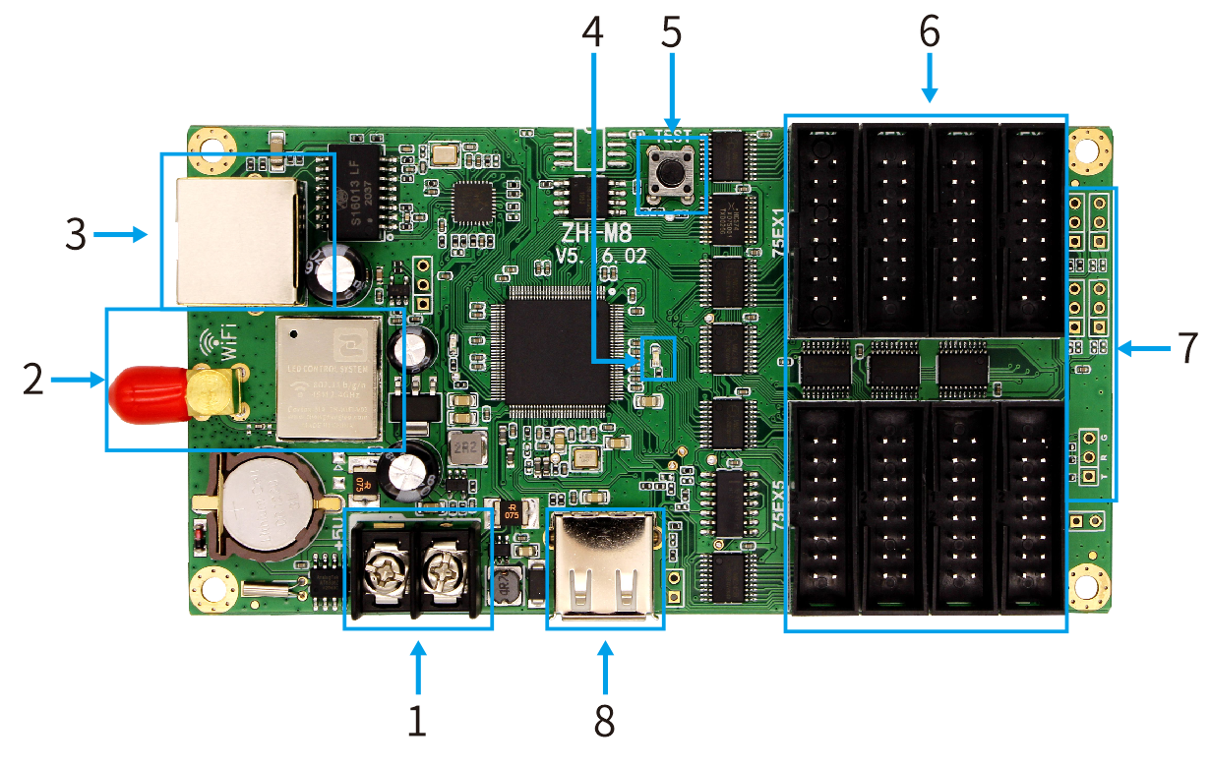

1. **Interface Function**

|  |  |  |  |
| --- | --- | --- | --- |
| NO. | Name: | Function: | Note: |
| 1 | Power input | Link DC5V power,offer power to card |  |
| 2 | WIFI antenna | Offer WIFI signal |  |
| 3 | LAN port | Connect to computer or switch or router to transmit data |  |
| 4 | Power indicator | Power state | Red color always light |
| 5 | Test button | Check WIFI SSID and test mode |  |
| 6 | HUB75E port | 75E data port |  |
| 7 | Expansion port | Expansion interface such as temperature sensor |  |
| 8 | USB port | Transfer USB content |  |

**B、Indicator:**

Power indicator: constant light indicates power supply;

**C、HUB75E:**

|  |  |  |  |  |  |  |  |
| --- | --- | --- | --- | --- | --- | --- | --- |
| Data signal | | | | Scan signal | | Control signal | |
| GD1 | Blank | GD2 | E | B | D | LAT | GND |
| 2 | 4 | 6 | 8 | 10 | 12 | 14 | 16 |
| 1 | 3 | 5 | 7 | 9 | 11 | 13 | 15 |
| RD1 | BD1 | RD2 | BD2 | A | C | CLK | OE |
| Data signal | | | | Scan signal | | Control signal | |

Note: HUB75 interface with scanning E signal, support 32 scanning display screen.

**D、External pin definition：**

|  |  |
| --- | --- |
| G | Sensor Ground line |
| S1/S2/S3/S4 | Sensor I/0 |
| 5V | Line to supply power to the sensor |

**V. Hardware Diagram:**

Unit: mm

